Research Data

# Data Presentation Plan for Material Flow Analysis (MFA) and Life Cycle Impact Assessment (LCIA)

Fig 1. Data Presentation Plan for Material Flow Analysis (MFA)

MFA: a tool to compile REEs data from extraction through end-of-life (EoL)

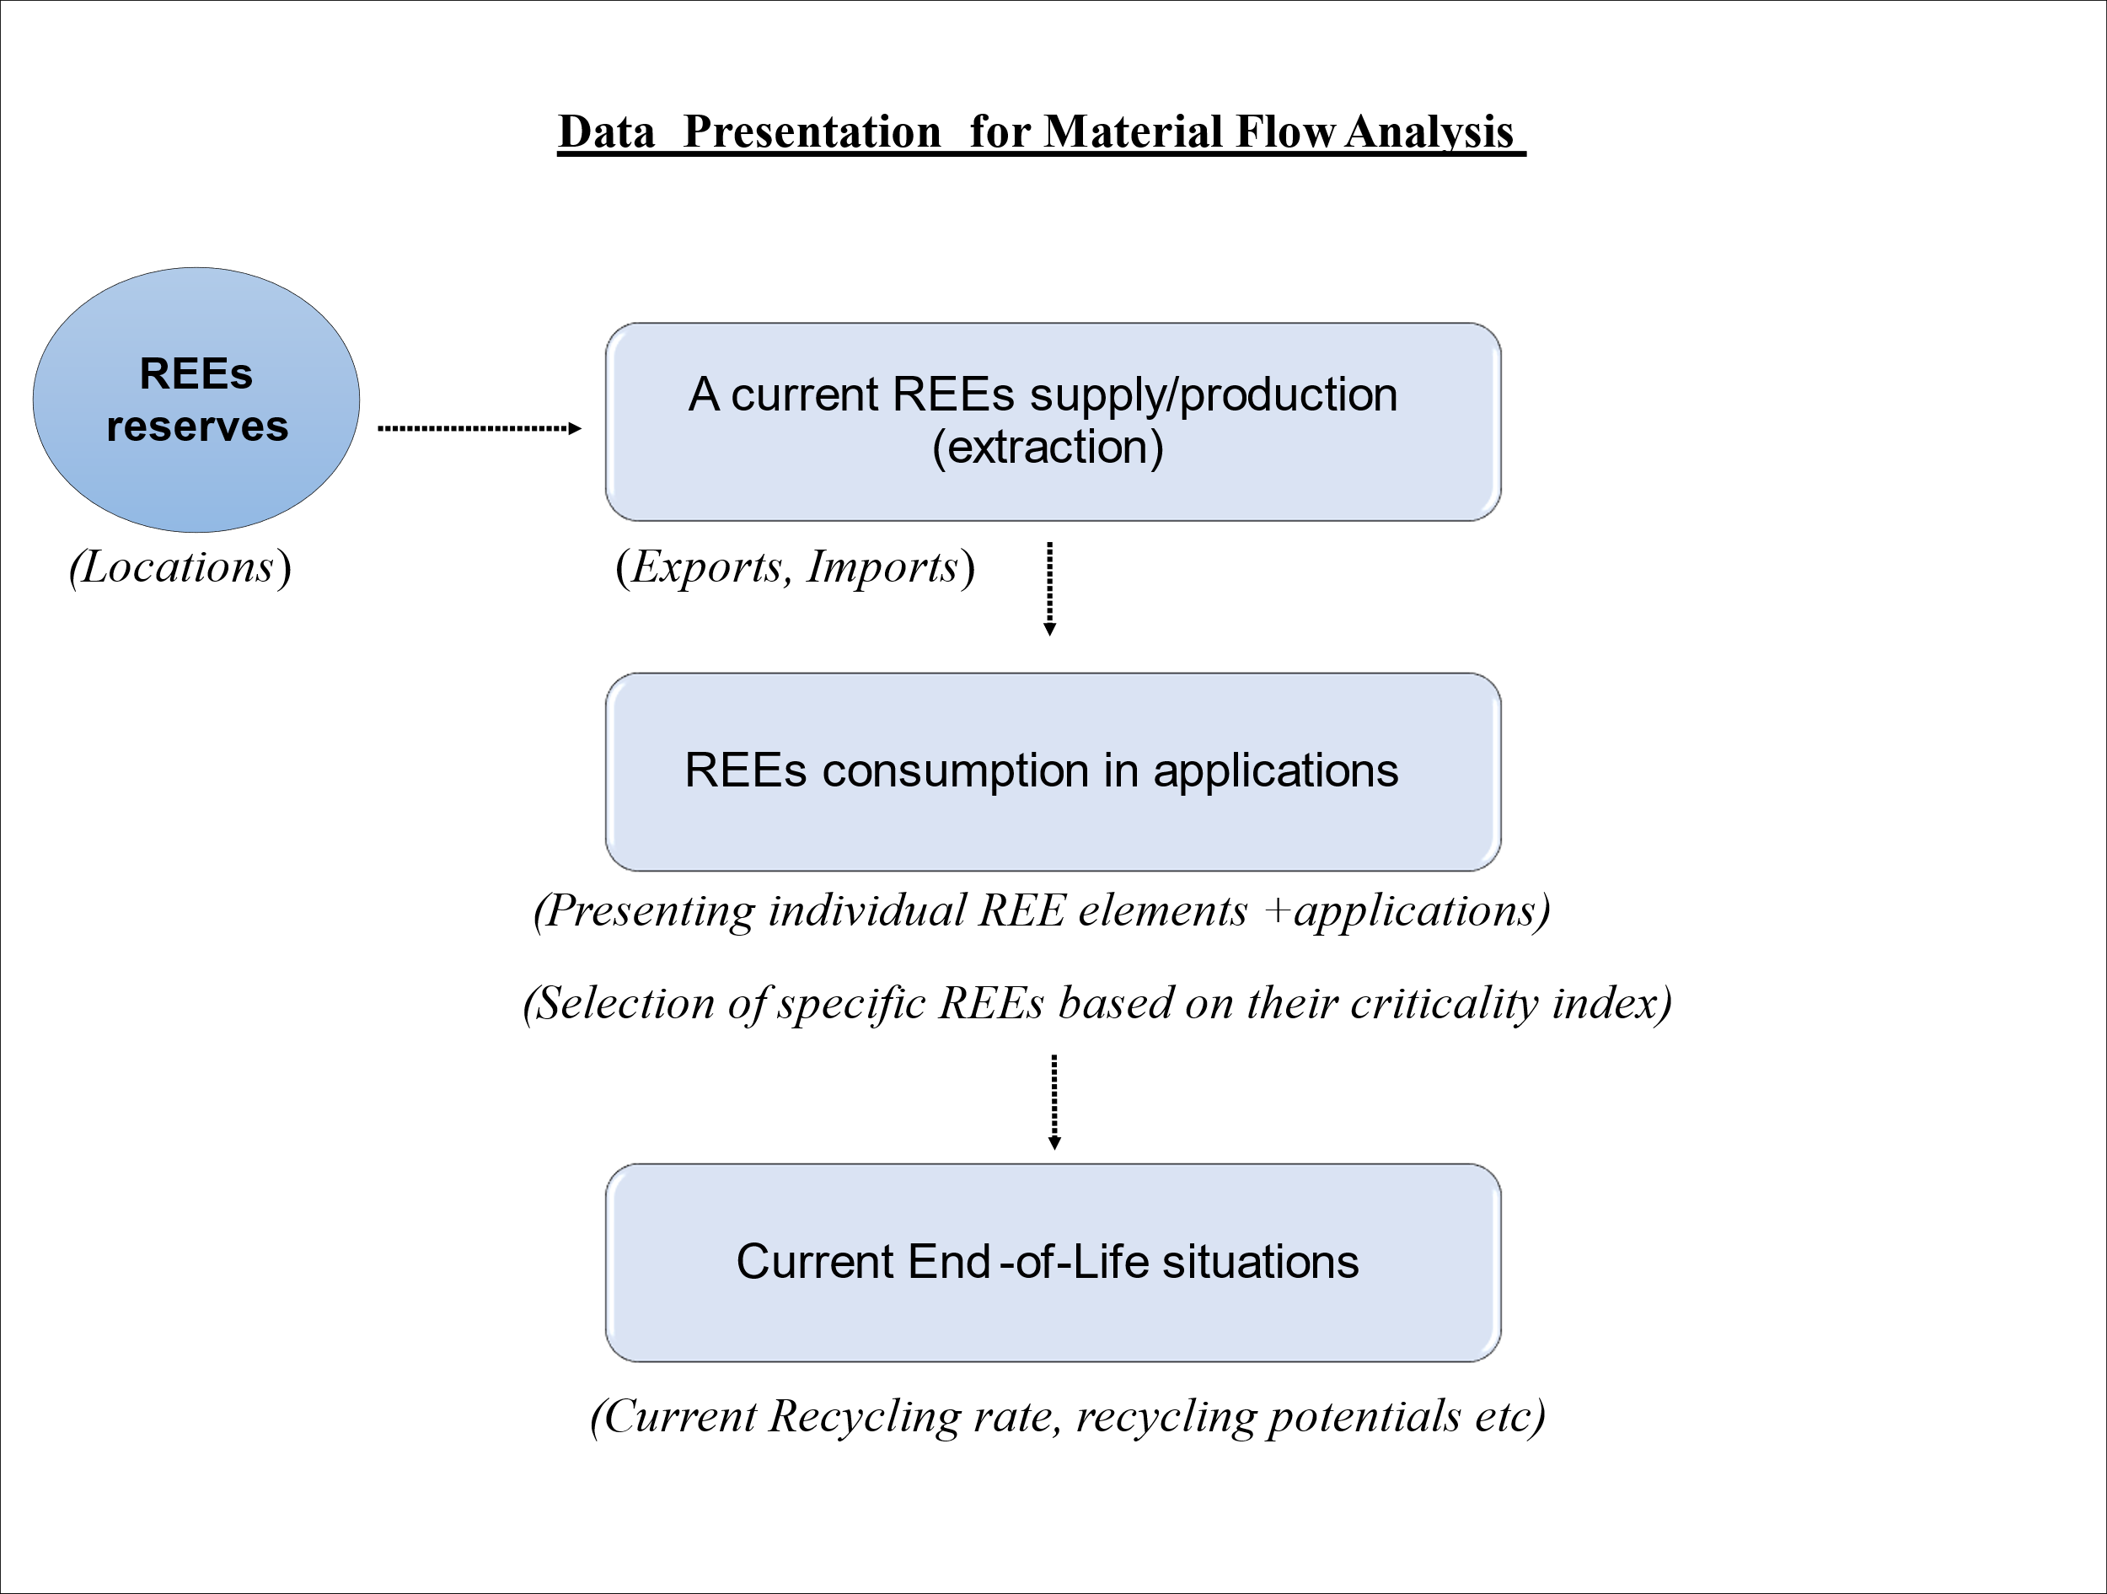

MFA serves as the tool recording materials and energy flow entering and leaving the system thus representing Life cycle inventory (LCI) which is later used to calculate life cycle impact assessment

Fig 2. Data Presentation Plan for Life Cycle Impact Assessment (LCIA)

LCIA: a tool to analyse the whole life cycle of data compilation for environmental impact assessment, policy and decision-making for societal benefit.

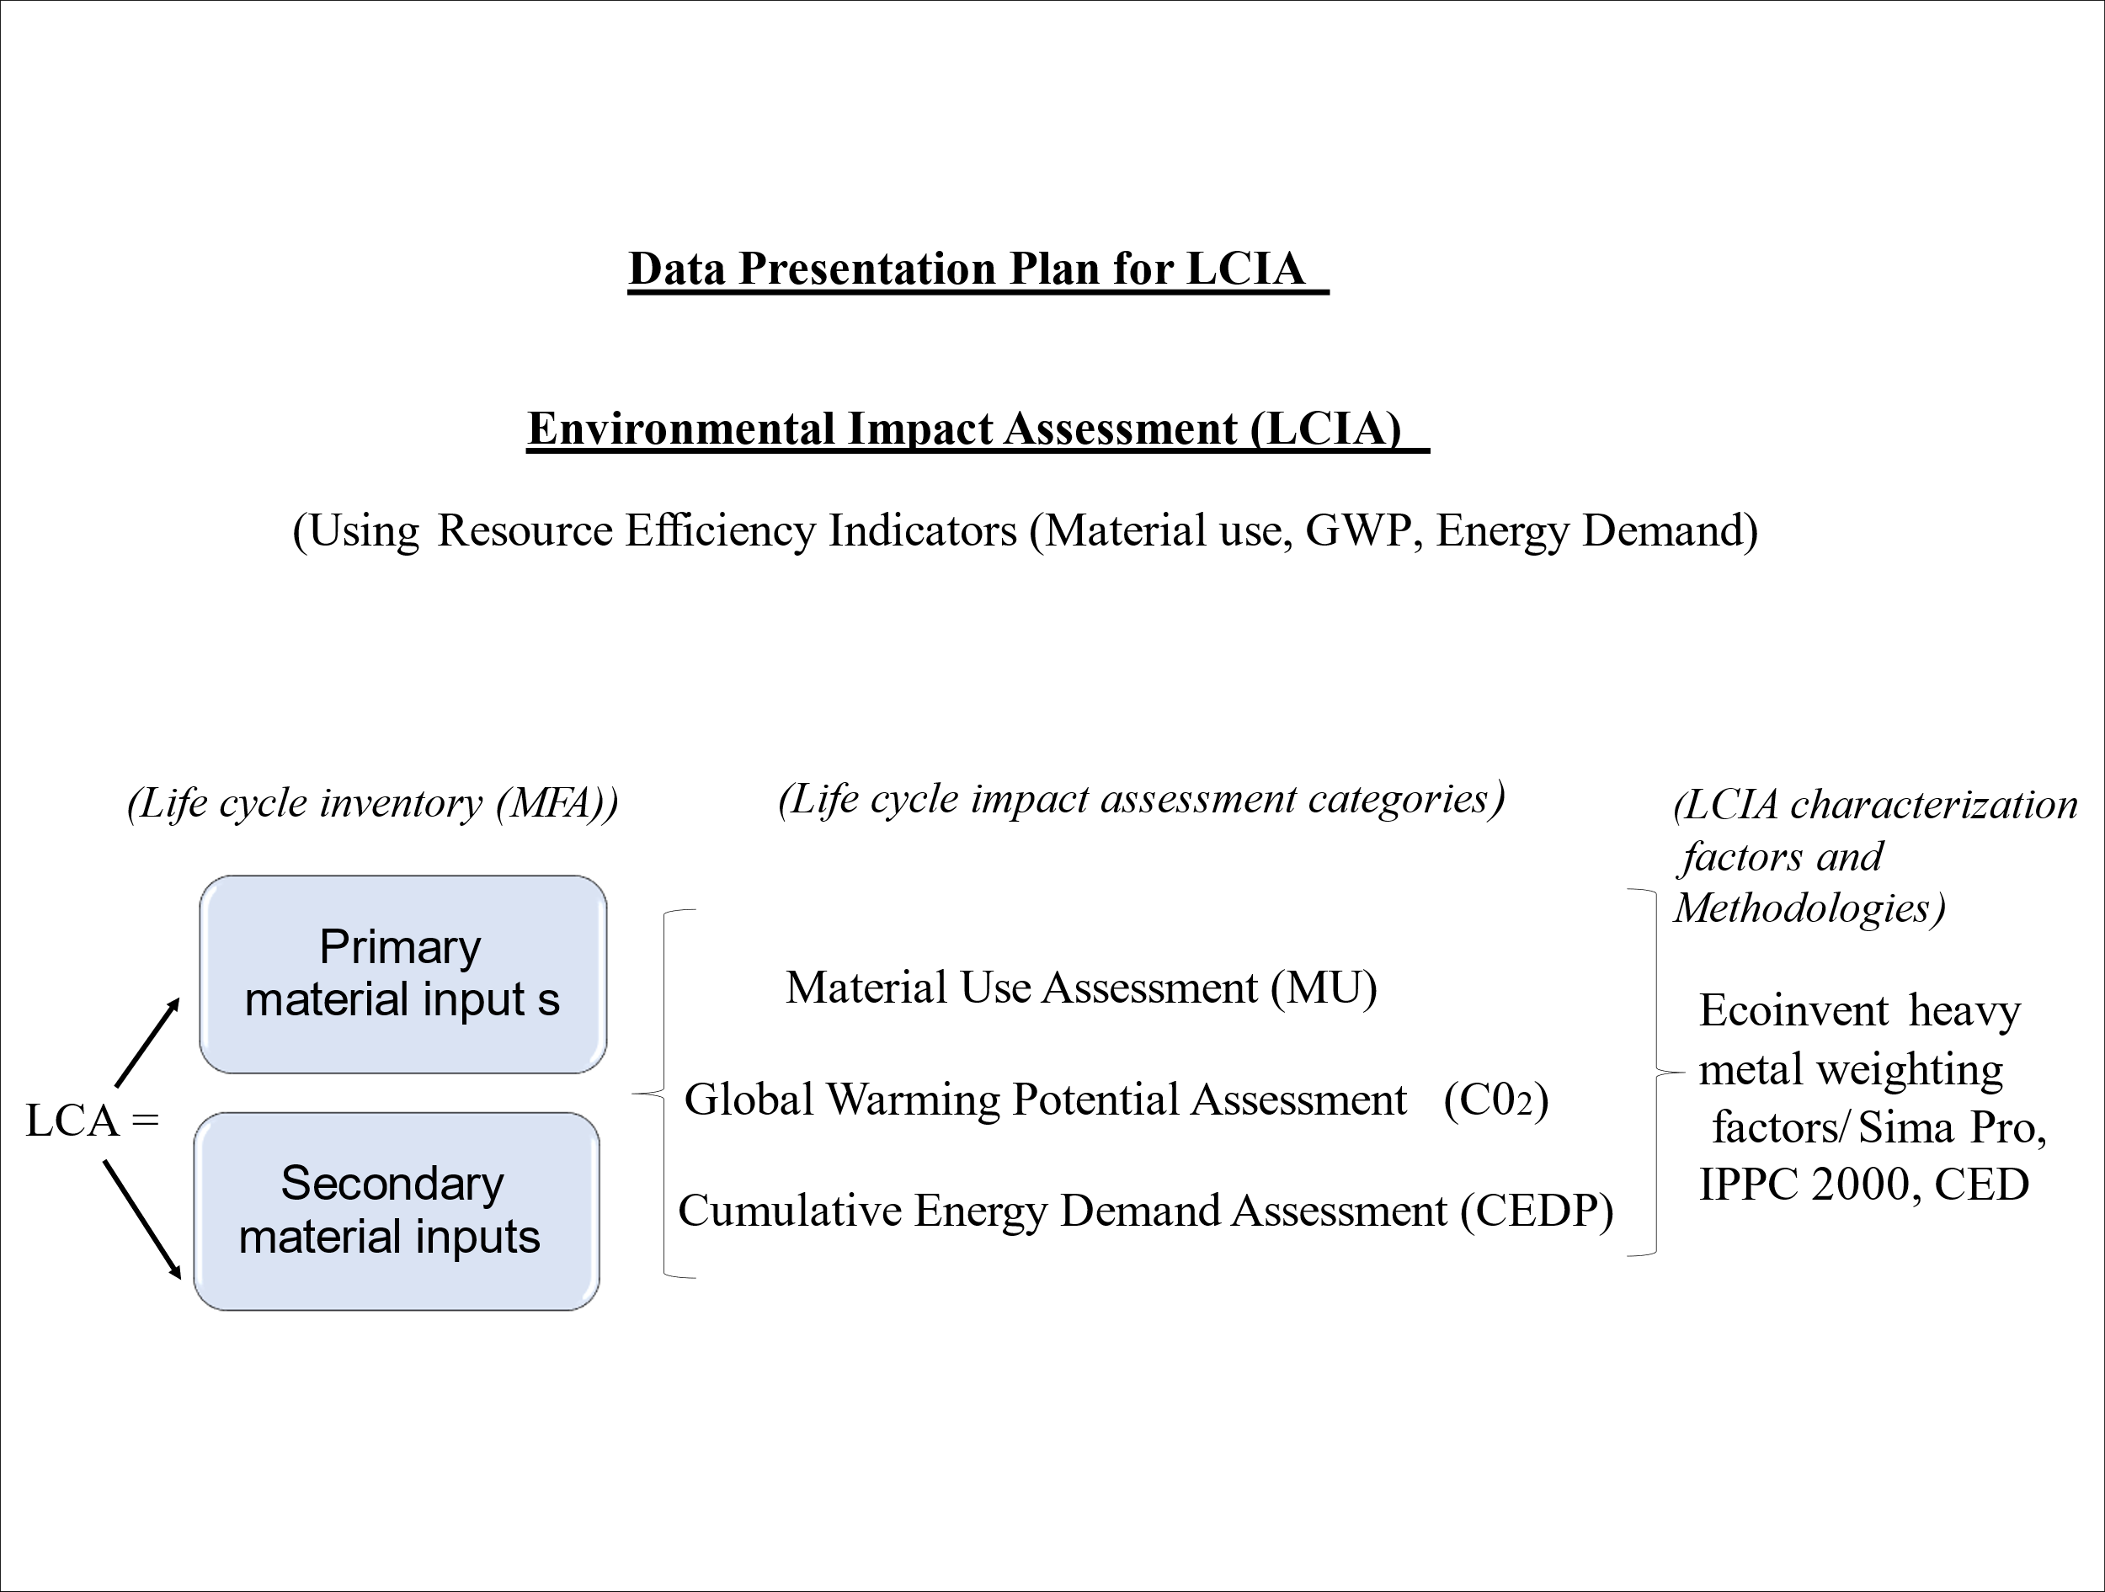

# REEs significance to clean technology and growth of a Green Economy

Fig 2. REEs significance to clean technology and growth of a Green Economy

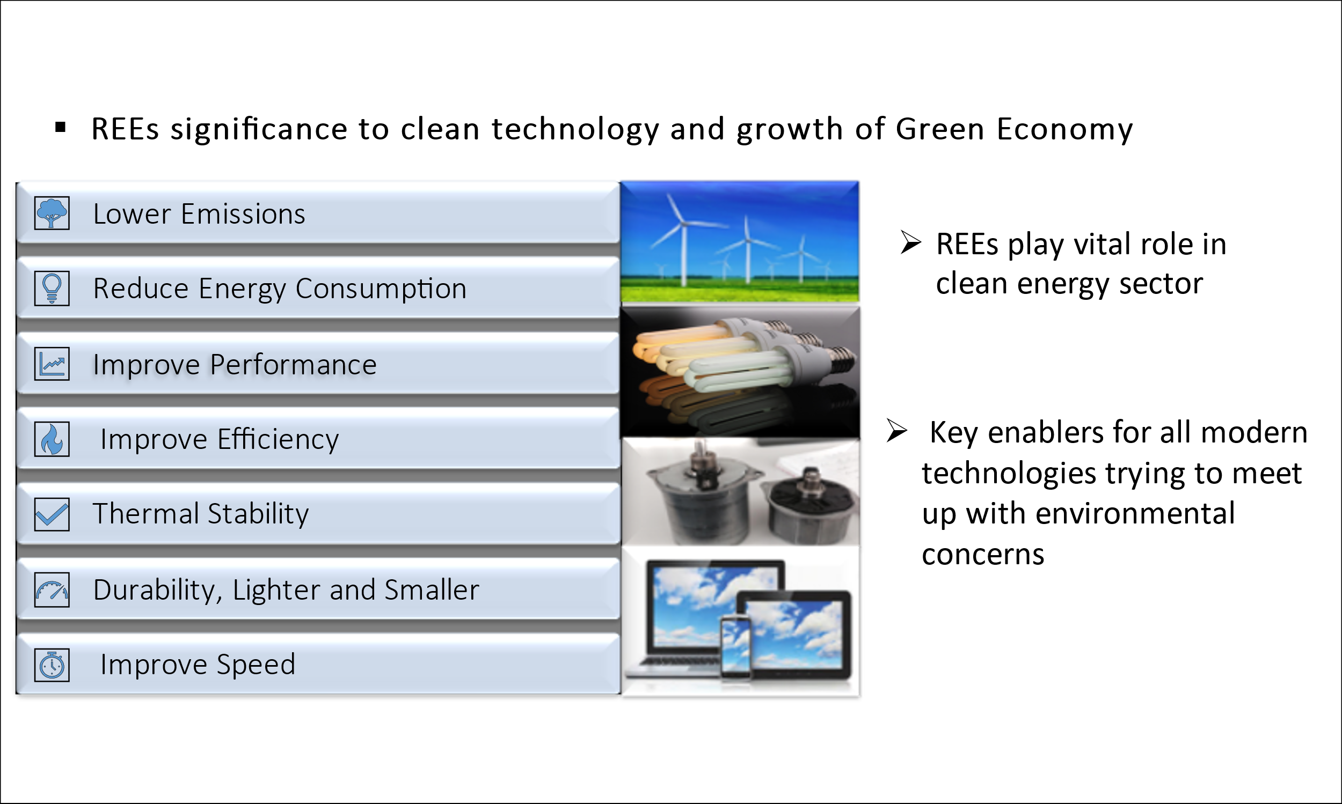

(Cai, 2019; Goonan, 2011; Huleatt, 2019; Lynas Rare Earths, n.d; Van Gosen et al., 2014)

# REEs Problems

Fig 3. REEs Problems: Graphical analysis

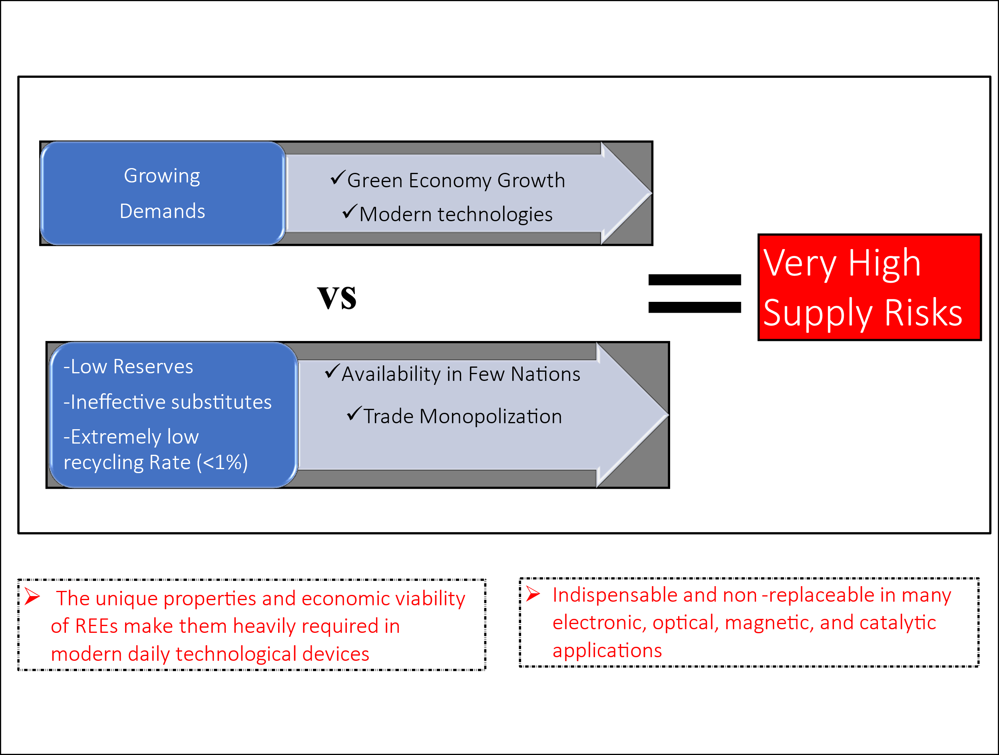

# REEs Consumption and Distribution

Table 1. REEs consumption Distribution. The estimated average consumption distribution by applications

|  |  |  |  |  |  |  |  |  |  |  |  |
| --- | --- | --- | --- | --- | --- | --- | --- | --- | --- | --- | --- |
|  | **REEs Usage in % by application** | | | | | | | | | | |
| **Applications** | La | Ce | Pr | Nd | Sm | Eu | Gd | Tb | Dy | Y | Others |
| Magnets | - | - | 23.4 | 69.4 | - | - | 2 | 0.2 | 5 | - | - |
| Battery Alloy | 50 | 33.4 | 3.3 | 10 | 3.3 | - | - | - | - | - | - |
| Metallurgy | 26 | 52 | 5.5 | 16.5 | - | - | - | - | - | - | - |
| Auto Catalysts | 5 | 90 | 2 | 3 | - | - | - | - | - | - | - |
| Fluide catalyst cracking (FCC) | 90 | 10 | - | - | - | - | - | - | - | - | - |
| Polishing Powder | 31.5 | 65 | 3.5 | - | - | - | - | - | - | - | - |
| Glass Additives | 24 | 66 | 1 | 3 | - | - | - | - | - | 2 | 4 |
| Phosphores | 8.5 | 11 | - | - | - | 4.9 | 1.8 | 4.6 | - | 69.2 | - |
| Ceramics | 17 | 12 | 6 | 12 | - | - | - | - | - | 53 | - |
| Others | 19 | 39 | 4 | 15 | 2 | - | 1 | - | - | 19 | - |

*Note*: The dash (-) represents no metal consumption in that end-use sector/application. **Source:** (Binnemans et al., 2013)

Table 2. The percentage of individual REEs consumption distribution by applications

|  |  |  |  |  |  |  |  |  |  |  |  |
| --- | --- | --- | --- | --- | --- | --- | --- | --- | --- | --- | --- |
|  | **REEs Usage by application tons, volume** | | | | | | | | | | |
| **Applications** | La | Ce | Pr | Nd | Sm | Eu | Gd | Tb | Dy | Y | Others |
| Magnets | - | - | 4.9 | 14.7 | - | - | 0.4 | 0.04 | 1.1 | - | - |
| Battery Alloy | 10.6 | 7.1 | 0.7 | 2.1 | 0.7 | - | - | - | - | - | - |
| Metallurgy | 5.5 | 11.0 | 1.2 | 3.5 | - | - | - | - | - | - | - |
| Auto Catalysts | 1.1 | 19.0 | 0.4 | 0.6 | - | - | - | - | - | - | - |
| Fluide catalyst cracking (FCC) | 19.0 | 2.1 | - | - | - | - | - | - | - | - | - |
| Polishing Powder | 6.7 | 13.7 | 0.7 | - | - | - | - | - | - | - | - |
| Glass Additives | 5.1 | 13.9 | 0.2 | 0.6 | - | - | - | - | - | 0.4 | 0.8 |
| Phosphores | 1.8 | 2.3 | - | - | - | 1.0 | 0.4 | 1.0 | - | 14.6 | - |
| Ceramics | 3.6 | 2.5 | 1.3 | 2.5 | - | - | - | - | - | 11.2 | - |
| Others | 4.0 | 8.2 | 0.8 | 3.2 | 0.4 | - | 0.2 | - | - | 4.0 | - |
| Sum | 57.3 | 80.0 | 10.3 | 27.2 | 1.1 | 1.0 | 1.0 | 1.0 | 1.1 | 30.3 | 0.8 |

*Note:* The dash (-) represents no metal consumption in that end-use sector/application.

Table 4. Australia REEs export 2019 in metric tons, Sum in kilotons (kt). Source: (WITS, 2019)

|  |  |
| --- | --- |
| **Countries** | **quantity** |
| New Zealand | 3.88298 |
| United States | 0.4 |
| United Kingdom | 10 |
| China | 0.0062 |
| France | 0.05 |
| Philippines | 0.0024 |
| New Caledonia | 0.005 |
| Total | 14.34658 |
| Sum in kt | 0.01 |

**Source:** (WITS, 2019)

Table 5. Australia REEs Import 2019 in metric tons, Sum in kilotons (kt)

|  |  |
| --- | --- |
| **Countries** | **Quantity** |
| China | 139.3777 |
| Germany | 0.30728 |
| Canada | 0.00135 |
| United States | 0.15944 |
| Russian Federation | 0.00045 |
| South Africa | 1.066 |
| Singapore | 0.016 |
| Japan | 0.0195 |
| Korea, Rep. | 0.005 |
| France | 0.00001 |
| United Kingdom | 2.002 |
| Total | 142.95473 |
| Sum in kt | 0.14 |

**Source:** (WITS, 2019)

Table 6. Global mine Production of REEs in percentages (%)

|  |  |  |
| --- | --- | --- |
| **Countries** | **Mine Production 2019** | **%** |
| United States | 26 | **12%** |
| **Australia** | **21** | **10%** |
| Brazil | 1 | **0.5%** |
| Myanmar | 22 | **10%** |
| Burundi | 0.6 | **0.3%** |
| China | 132 | **62%** |
| India | 3 | **1%** |
| Madagascar | 2 | **1%** |
| Russia | 2.7 | **1%** |
| Thailand | 1.8 | **1%** |
| Vietnam | 0.9 | **0.4%** |
| World total (rounded) | 210 | 100% |

**Source**: (Huleatt, 2019; U.S. Geological Survey, 2020)

# Life cycle methodologies characterisation factors from ecoinvent

Table 7. CO2 emission weighting/characterisation factors/IPCC GWP 100a 2013/ecoinvent database/Simapro

|  |  |
| --- | --- |
| **Weighting Factors IPCC GWP 100a 2013** | |
| Metals | (Kg CO2-eq) |
| Nd | 50.82 |
| Dy | 1.2079 |
| Eu | 0.97337 |
| y | 29.371 |
| Tb | 3.0677 |

Table 8. CEDP weighting/characterisation factors ecoinvent database/Simapro non-renewable energy resources, fossil

|  |  |
| --- | --- |
| **Weighting Factors CEDP** | |
| Metals | MJ-Eq |
| Nd | 590.51 |
| Dy | 13.995 |
| Eu | 12.15 |
| Y | 336.62 |
| Tb | 35.3 |